**RESULT AND DISCUSSION**

1. **User Login / Default Home Page:**

The User Login page is a crucial component of the hostel management system, providing safe access for authorized users. The website features streamlined navigation and a sidebar for simple access to relevant tasks, as well as user-friendly login and password entry fields.

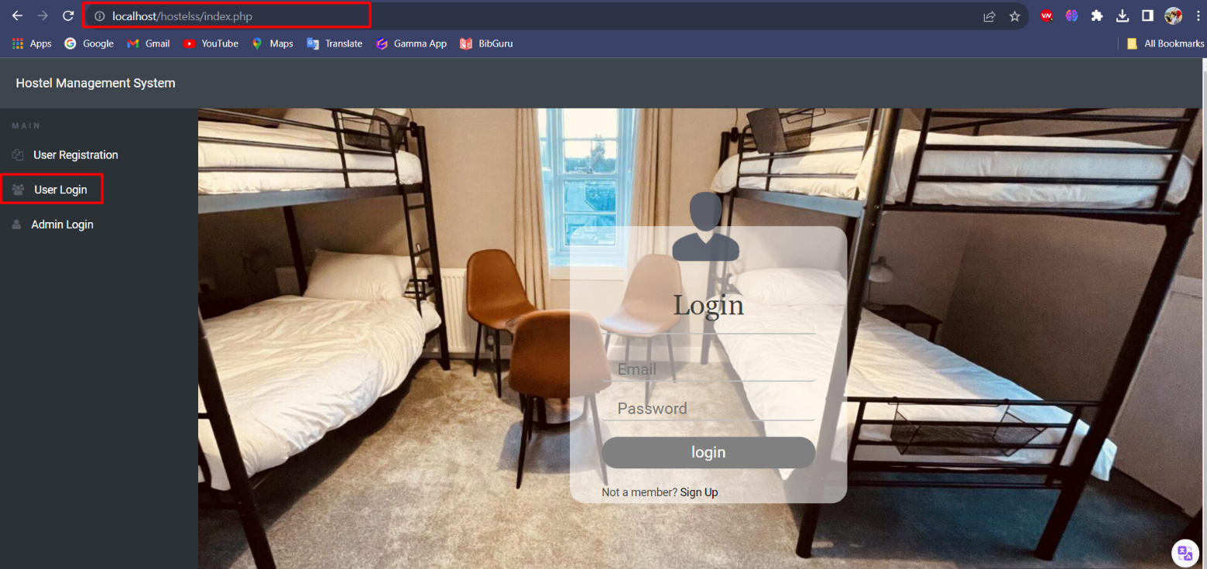

This is the default page to enter the project interface. When you type “**localhost/hostel”** in the browser it redirects to this **index.php**. In this page it has a Navbar consist of **“Hostel Management System”.**

Its recognizable and dependable branding makes sure that consumers understand the system's background and goal. Users can utilize the navigation bar as a point of reference when navigating between the different areas of the website.

Also, a sidebar which consist of **“User Registration”, “User Login” and “Admin Login”.**

The sidebar improves the navigation bar with its quick access to important items. The three main options are as follows:

* **User Registration**: New users can create an account on the website by using this function. It facilitates the initial steps for anyone wishing to use services associated to hostels.
* **User Login**: This section allows current users to securely log in and acts as the heart of the website. By inputting their login and password, users can access information and services that are specific to them.
* **Admin Login**: This section is dedicated to administrators who oversee and oversee hostel operations. In addition to handling duties related to user management, hostel amenities, and other areas, administrators have access to additional functionality.

In here we can see a login page to enter into the Hostel Management System. In this login form you need to type your **Email** and **Password.** In order to verify the Email and Password the system will check this or verify this using the data in the database called **“HostelSS”.**

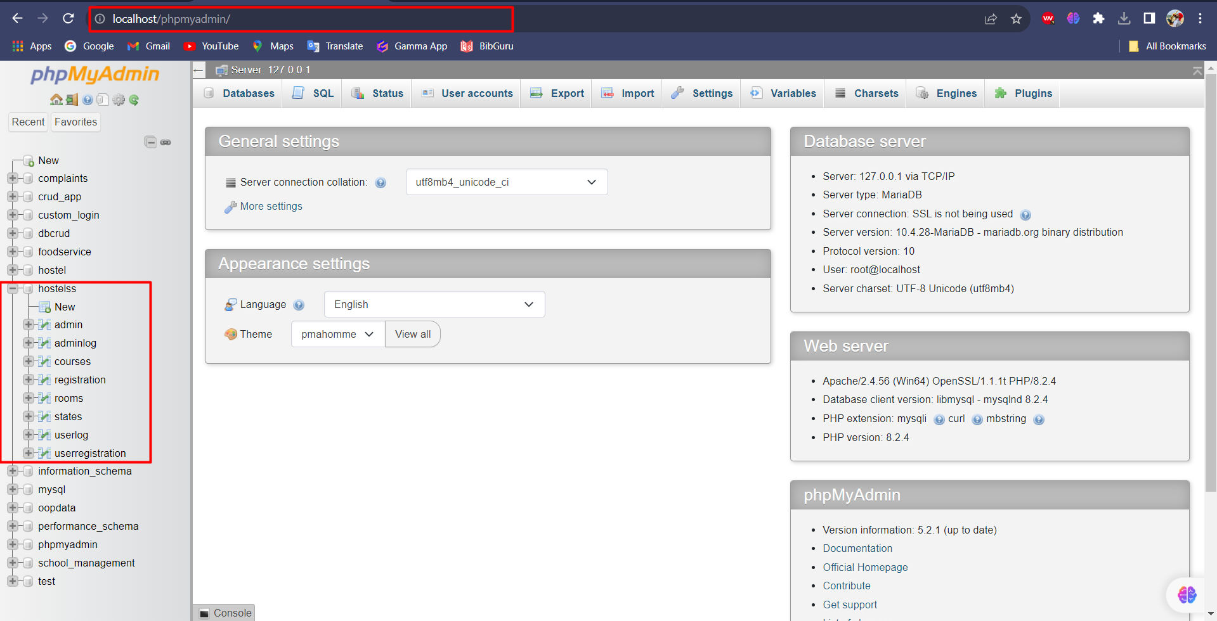

Here I have this database inside my localhost. So, from this table I have a table called **“userregistration”.** From this table we have user details.

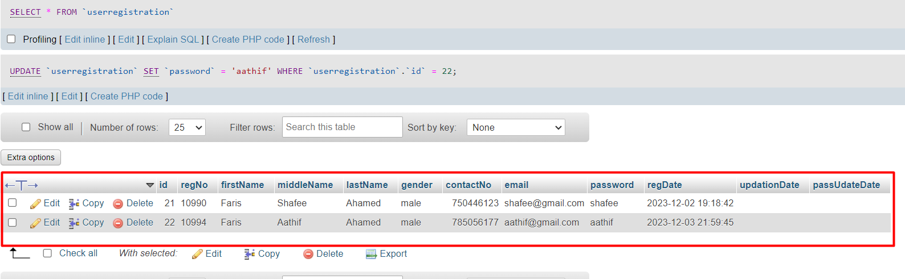

Here I have a dummy data to verify my user login. Using this I can verify and authenticate to user home page. If the **Email** and **Password** which you enter matches with the data in the table matches only it’ll log in to the home page.

1. **User Registration**

When you don’t have a user account to login this is the page that you’ll needed to create an account to login. When you click on this User Registration, you’ll redirected to User Registration page.

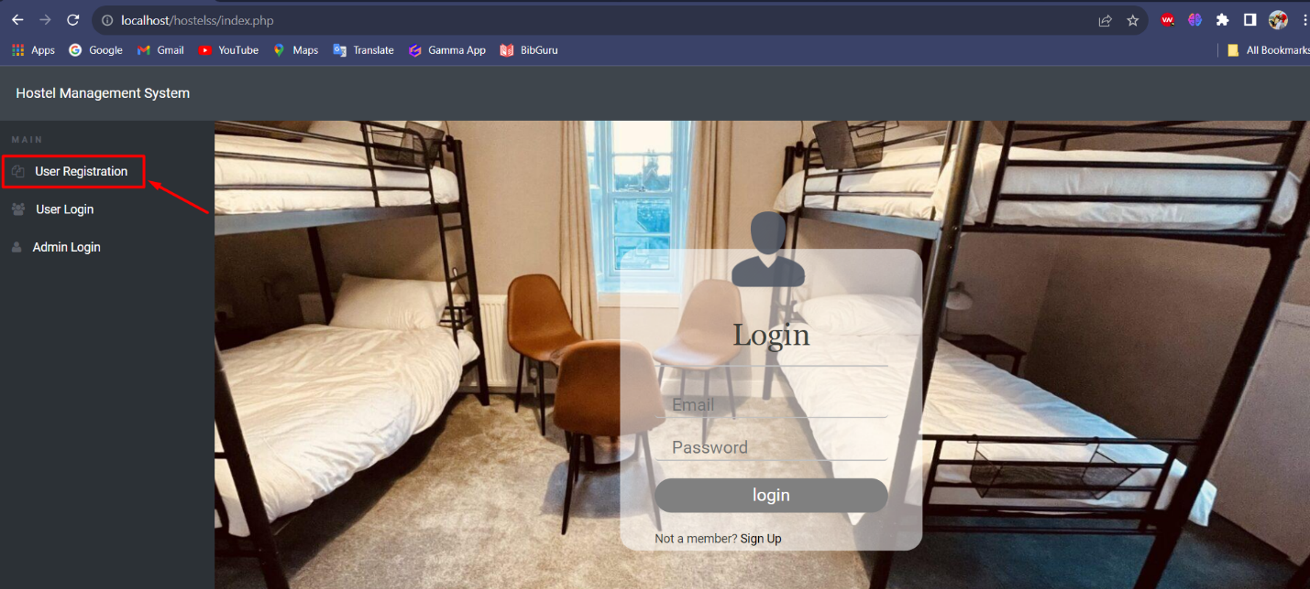

The User Registration Page, which serves as a gateway for users to access and manage their accounts in the system, is a crucial component of the Hostel Management Website. With a focus on crucial data elements including the Registration Number, Email ID, Gender, First Name, Last Name, and Middle Name, in addition to the Contact Number, Password and Confirm Password.

The main goal of the User Registration Page is gathering the data needed from students of the hostel in order to create unique user accounts that will provide easy access to the Hostel Management System. This page guarantees reliable record-keeping inside the database and forms the basis for customized user experiences.

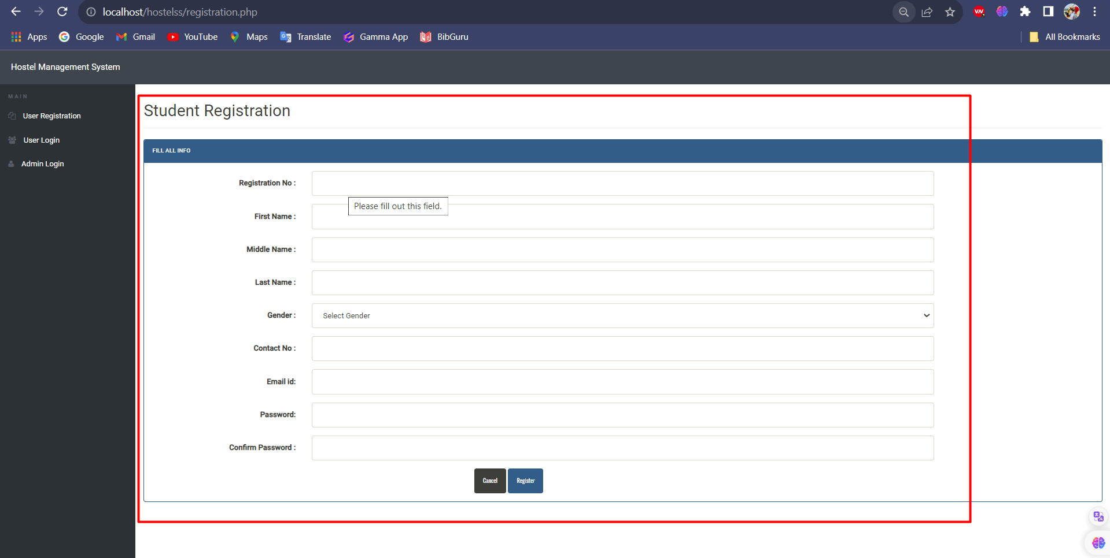

Every hostel resident is assigned a registration number, which functions as a distinct identity and facilitates tracking and administration.

Input fields of the User Registration Page

* **First Name, Last Name, Middle Name:** These are the fields used to properly document the resident's name so that their identity can be verified.
* **Gender:** Allows renters to specify their gender in order to receive personalized communications and be assigned to a hostel.
* **Contact Number:** Crucial for correspondence and emergency contact in the event of a crisis.
* **Email ID:** Unique email addresses serve as login credentials and a channel for interaction with the hostel management.
* **Password, Confirm Password:** By requiring a combination of alphanumeric, special, and alphabetic characters, it adds an additional layer of security to user accounts.

After successfully registering, users receive a confirmation message. And also, the data that he entered will be pass to the database table called userregistration. In the event that any issues or details are missing, helpful error messages assist users in making the required corrections.

1. **User Dashboard**

After login in the login page if the Email and Password are correct, you’ll redirected to the below User Dashboard Page

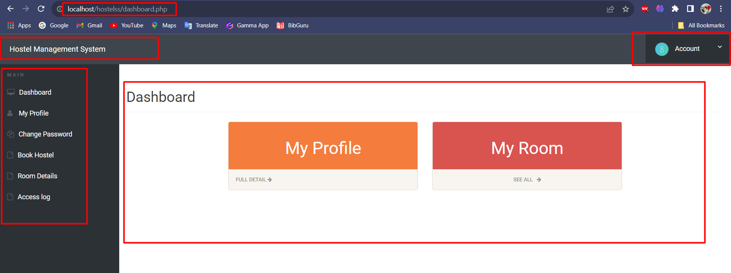

If the login failed, you’ll get notification like below

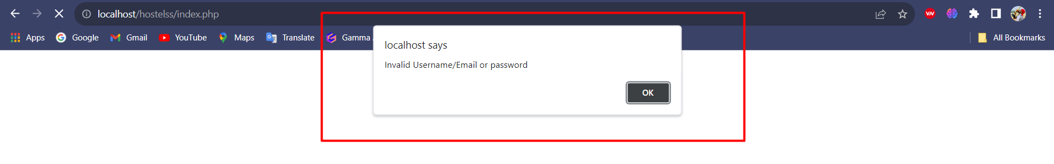

If the login failed, you’ll get an alert like the above.

Now when you logged in and in the User Dashboard. You’ll get a navbar with our Project Name and Side bar with the contents

In the Navbar you’ll see



Hostel Management System and one drop down type list with an icon. Here when you click on that Account

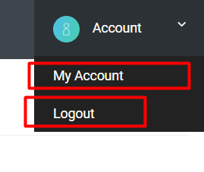

Now when you click Account, you’ll get two things in the drop down. One is **“My Account”** the other thing is **“Logout”.**

**My Account:** When you click this, you’ll redirected to your profile which is my-profile.

**Logout:** When you click this, you’ll be logged out from your account.

In the Side Bar you’ll see

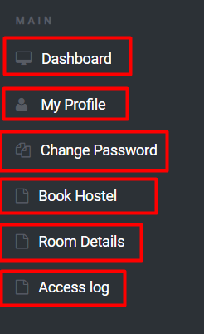

**Dashboard:** Dashboard is the default page after the login.

**My Profile:** My profile is the page which contains user details.

**Change Password:** This option gives you an option to change your password.

**Book Hostel:** Here this option gives an option to book hostel for the user.

**Room Details:** This page will give you the rooms details

**Access log:** This option will tell your login date time and entries.

In the body of User Dashboard, you’ll see the below things

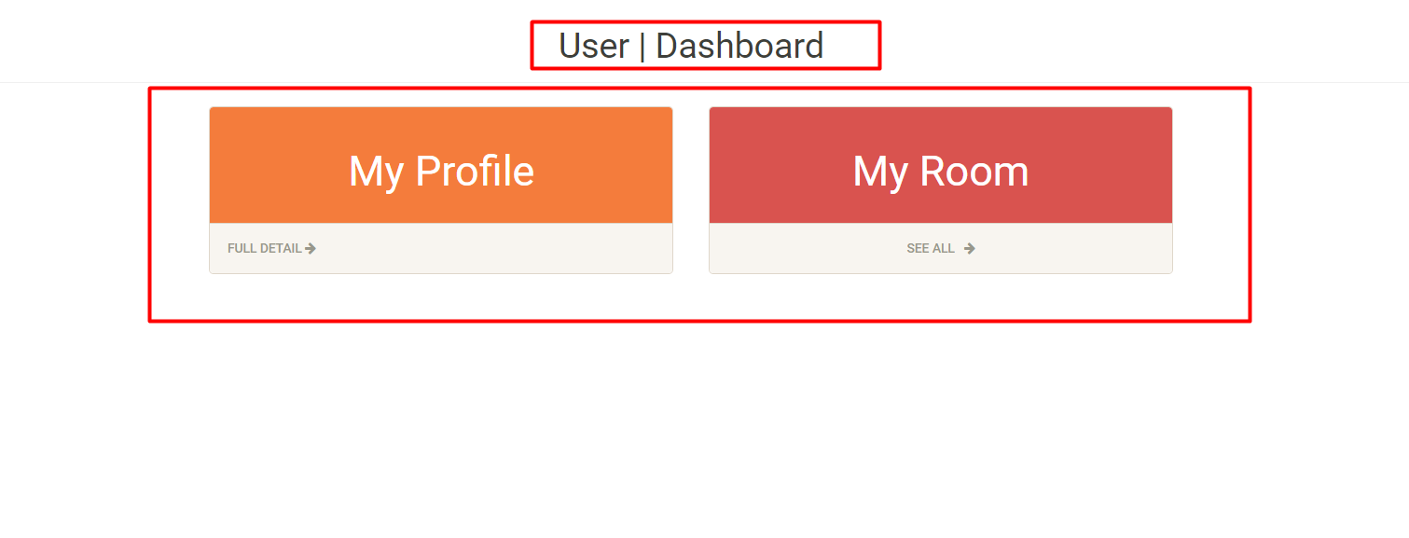

In here, when you click on My Profile it’ll redirected to your profile page and when you click on My Room, you’ll go to your room Details.

1. **My Profile**

When you click on **“My Profile”** in the sidebar of the dashboard

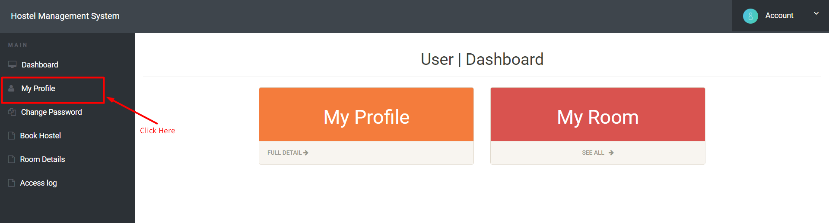

You’ll be redirected to your profile page which contains your personal information.

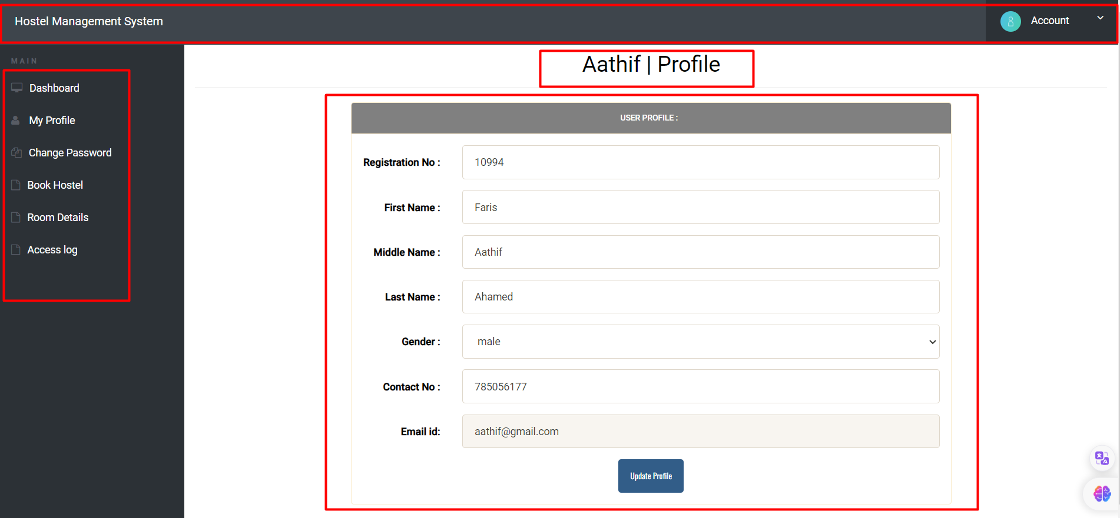

Here also you’ll get the same Navbar and Sidebar. But in the body of that My Profile you’ll get your Personal Information in a form like structure with the specific field name.

Here you’ll get your information from Database table. If you want to change or edit something you can edit and click on the button **“Update Profile”.** Once you click enter your changes will be altered in the Database **“userregistration”** table.

For Example,

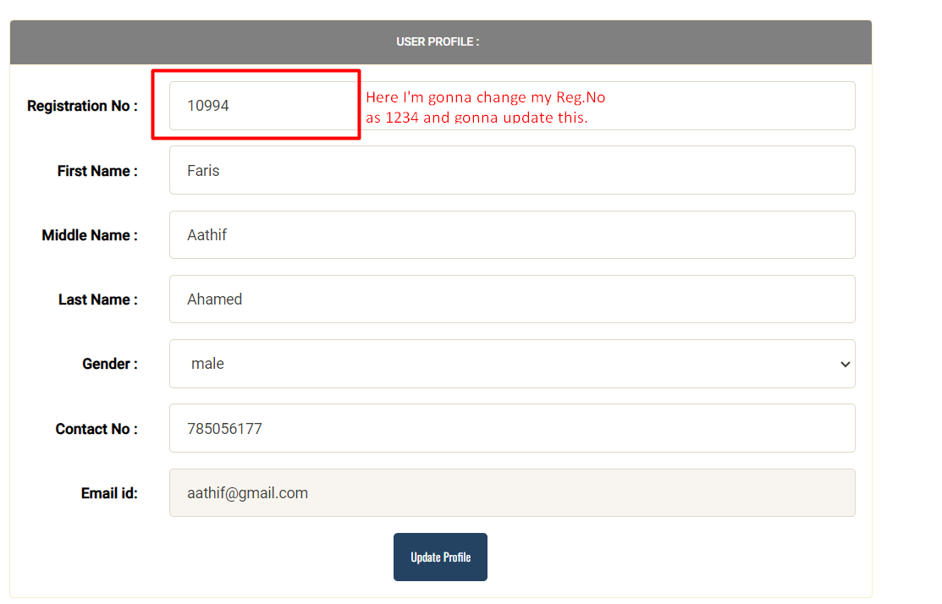

If I change and hit the update button, I’ll get like below.

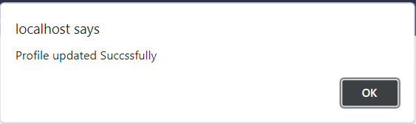

We’ll get an alert saying that we have successfully updated our information. And also, it’ll change in the database userregistration table



1. **Change Password**

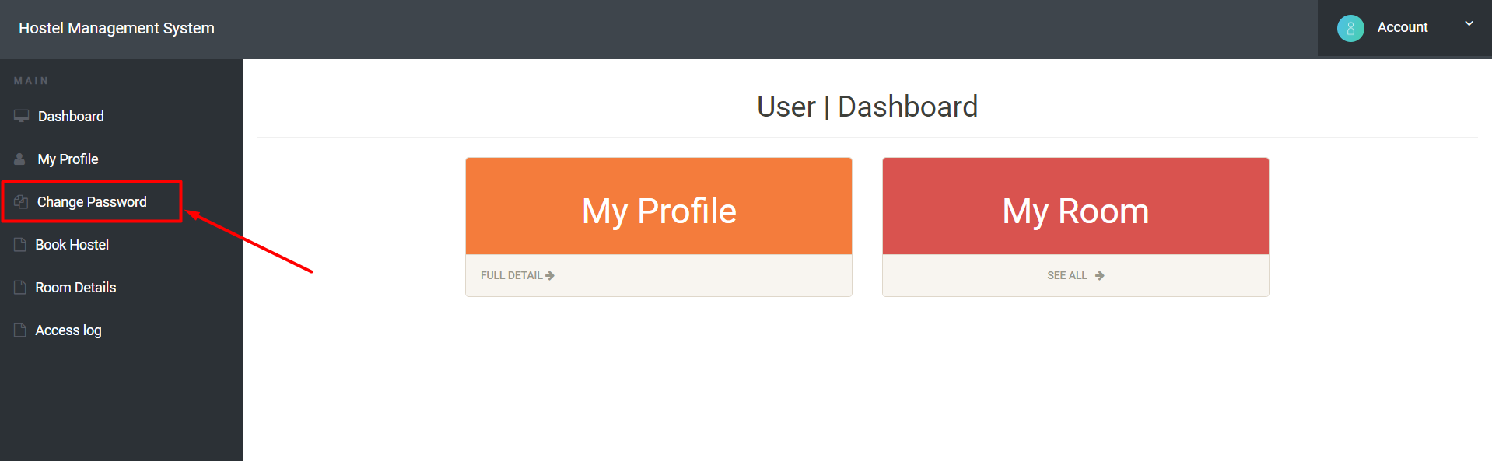

When this Change Password is clicked it’ll go to the change password page

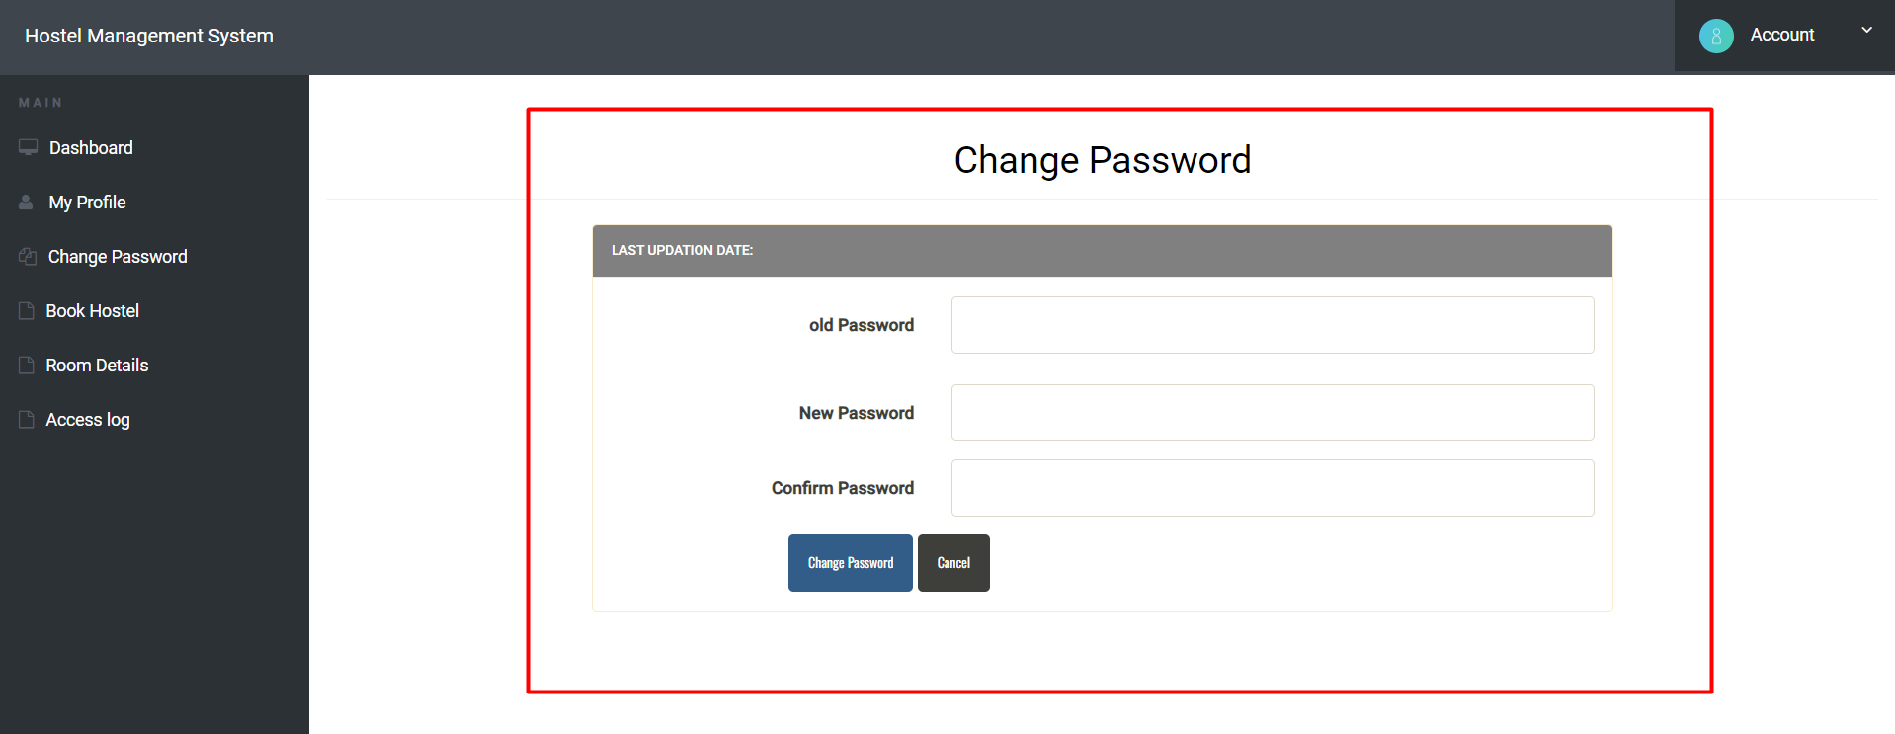

In the Change Password Page, we’ll get a form like structure to change our password. For that we need to give our **“old password”, “New Password”, and “Confirm Password”.** If the Old password is correct only, we can change otherwise it’ll show you the error.

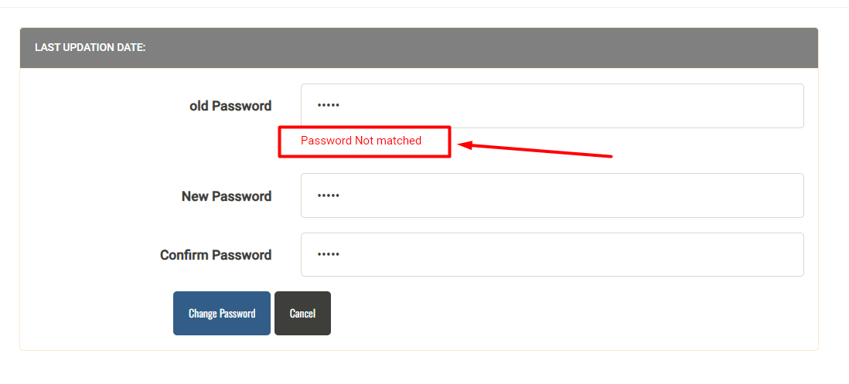

When you give the old password wrongly, you’ll get an alert saying that Password Not Matched. If the old password is correct, you’ll get like below

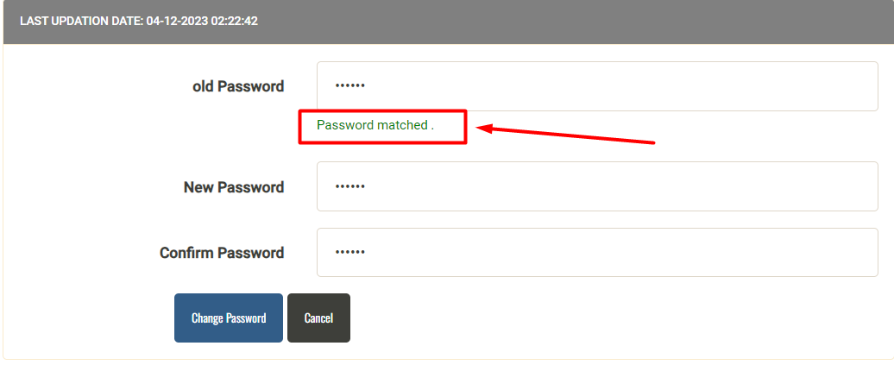

If the old password that you’ve entered is correct, you’ll get a green color Password Matched message.

If you give everything correct and changes the password, you’ll notify like this

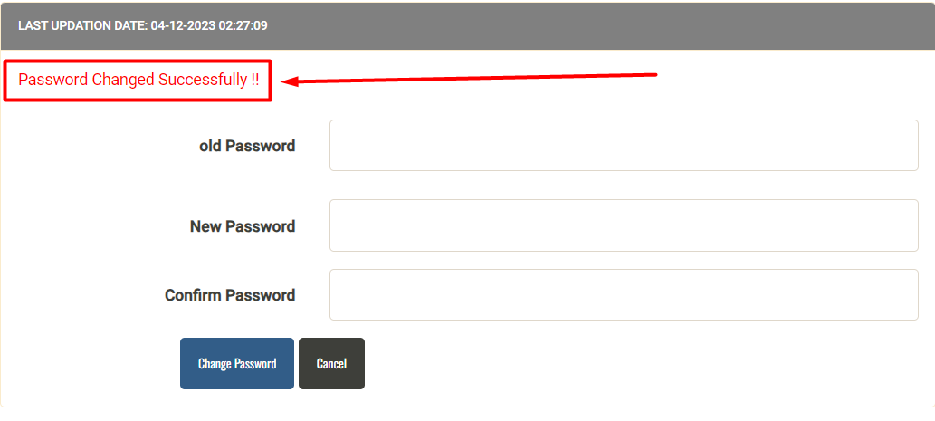

And also, the changes will be updated in the database table also.

1. **Book Hostel**

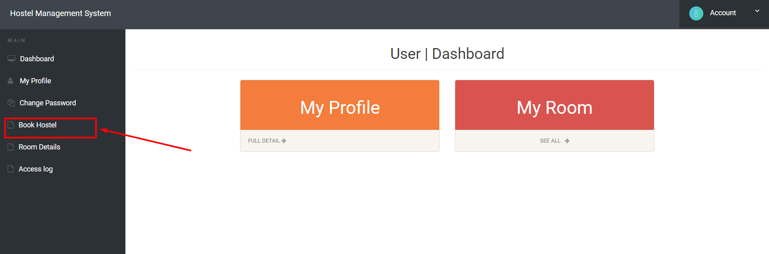

When you click on the **“Book Hostel”** you’ll go to the page to book a hostel room for you. If you didn’t create anything it’s fine but if you created already, you’ll get a red color text warning message in the page itself.

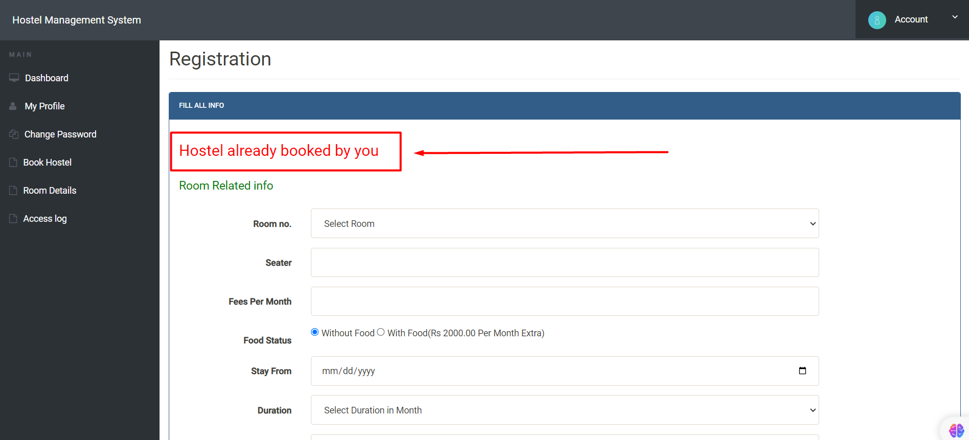

In this user case, I’ve already booked a room for them. If I take a new User it’ll show like below.

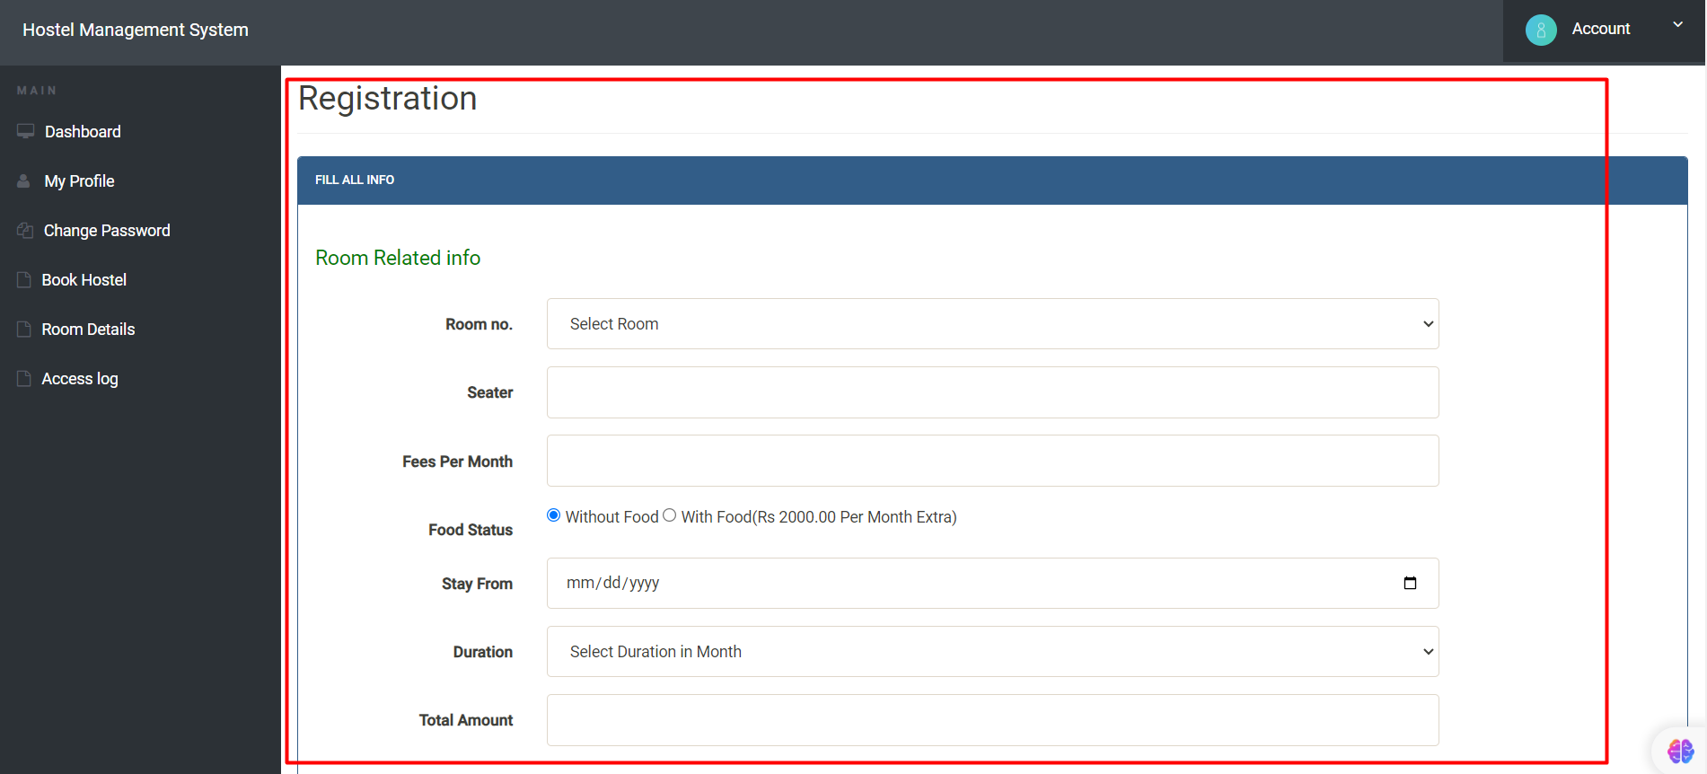

We won’t see anything like **“Hostel Already Booked by You”** when the Hostel room is not booked. And you need to fill all the required information in this registration form and submit. It’ll automatically updated in the database table called **“registration”.**

In my case, I’ve applied for two users in the database registration table.

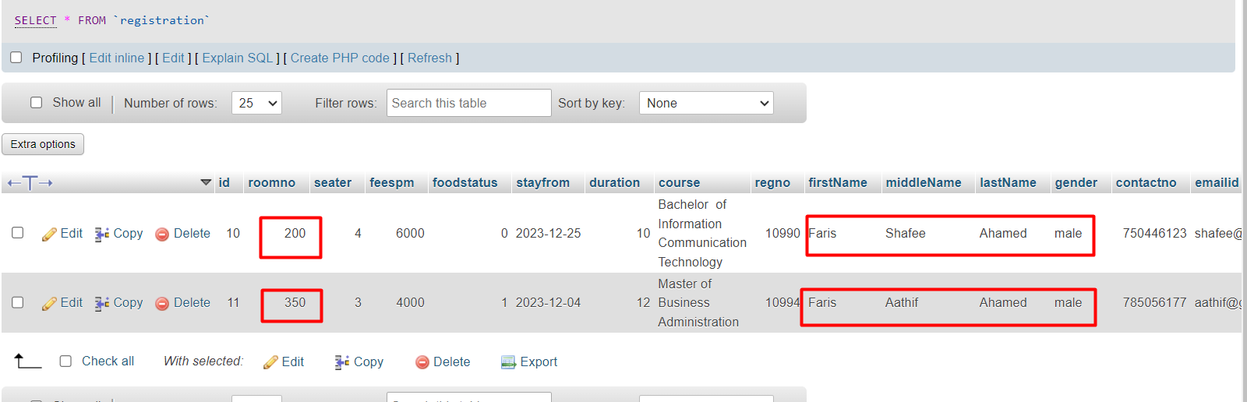

1. **Room Details**

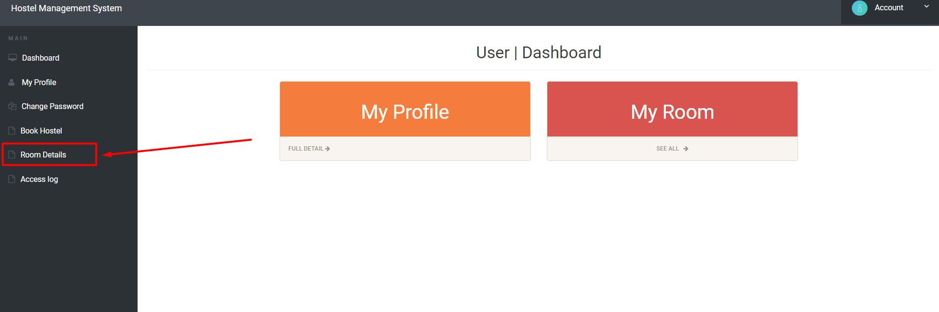

When you click on Room Details, you’ll be navigated to you room related info

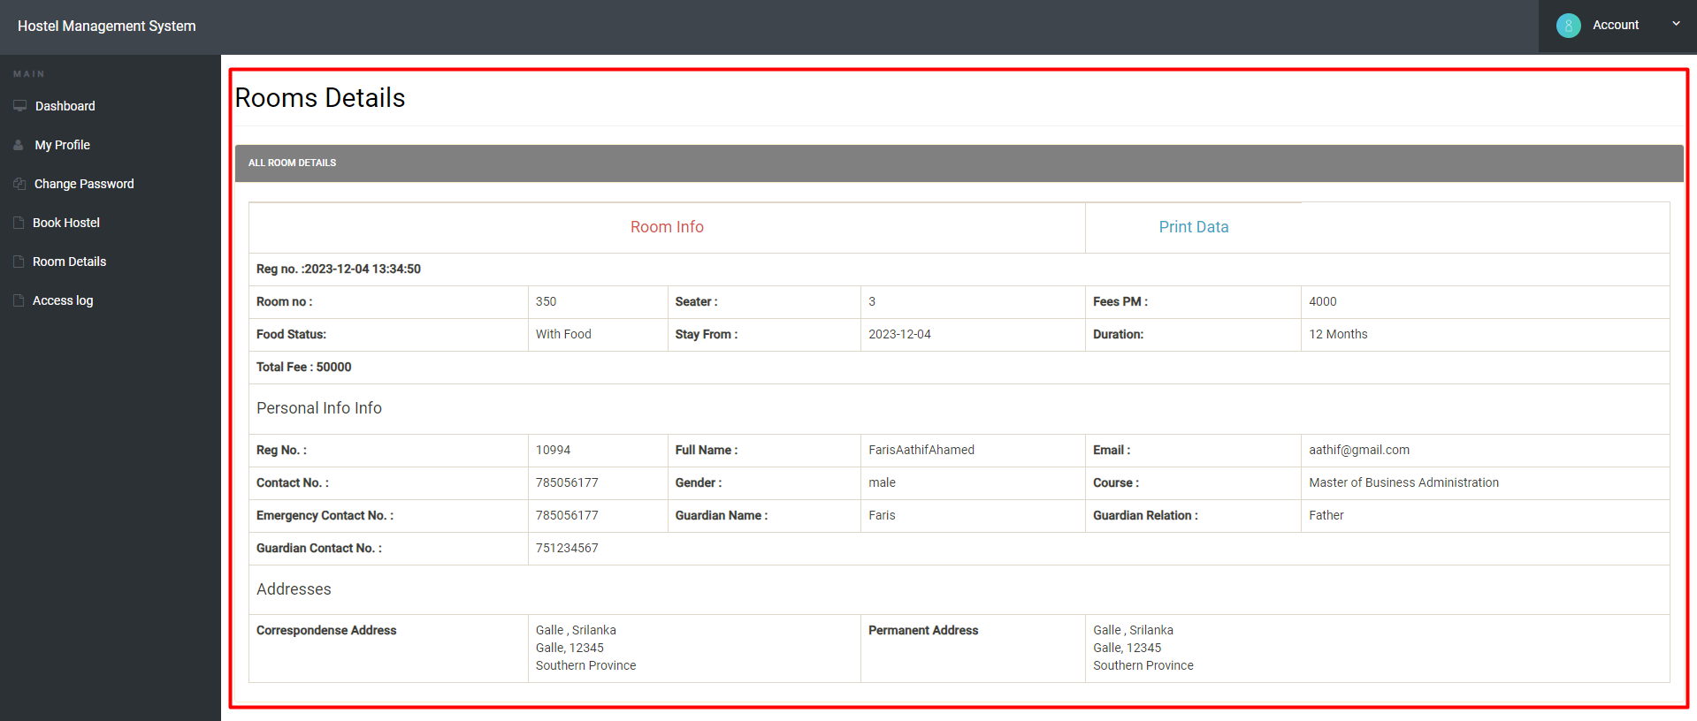

From this table you can view your information and if you want you can print the data using **“Print Data”.**

1. **Access Log**

The Access Log Page is one of the most crucial tools for keeping an eye on user activity within a system or application. It is a record-keeping feature designed to capture crucial information such as times, dates, and user log-in details. Each user can see their own login details.

In the dashboard page user need to click on Access log.

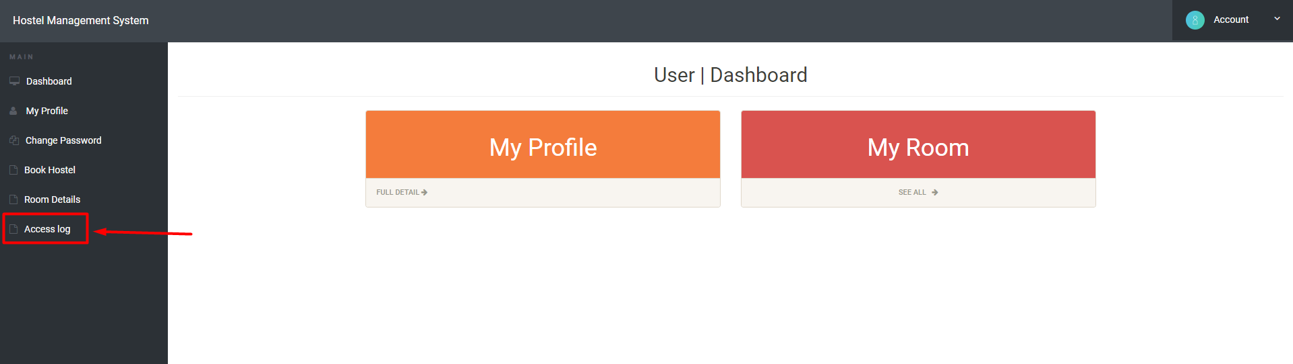

When the user clicks on Activity log, it’ll go to the Access Page

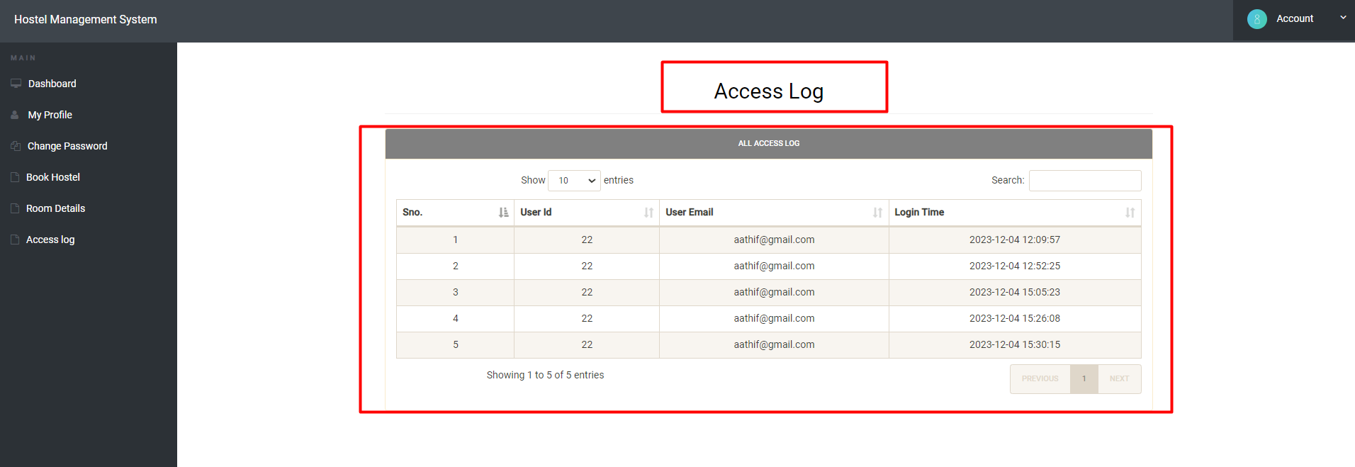

By offering a clear record of user activity, an Access Log Page helps to promote user accountability. This functionality complies with industry regulations requiring compliance in a number of areas where user activity tracking and auditing is crucial for privacy and data security.

1. **Admin Login**

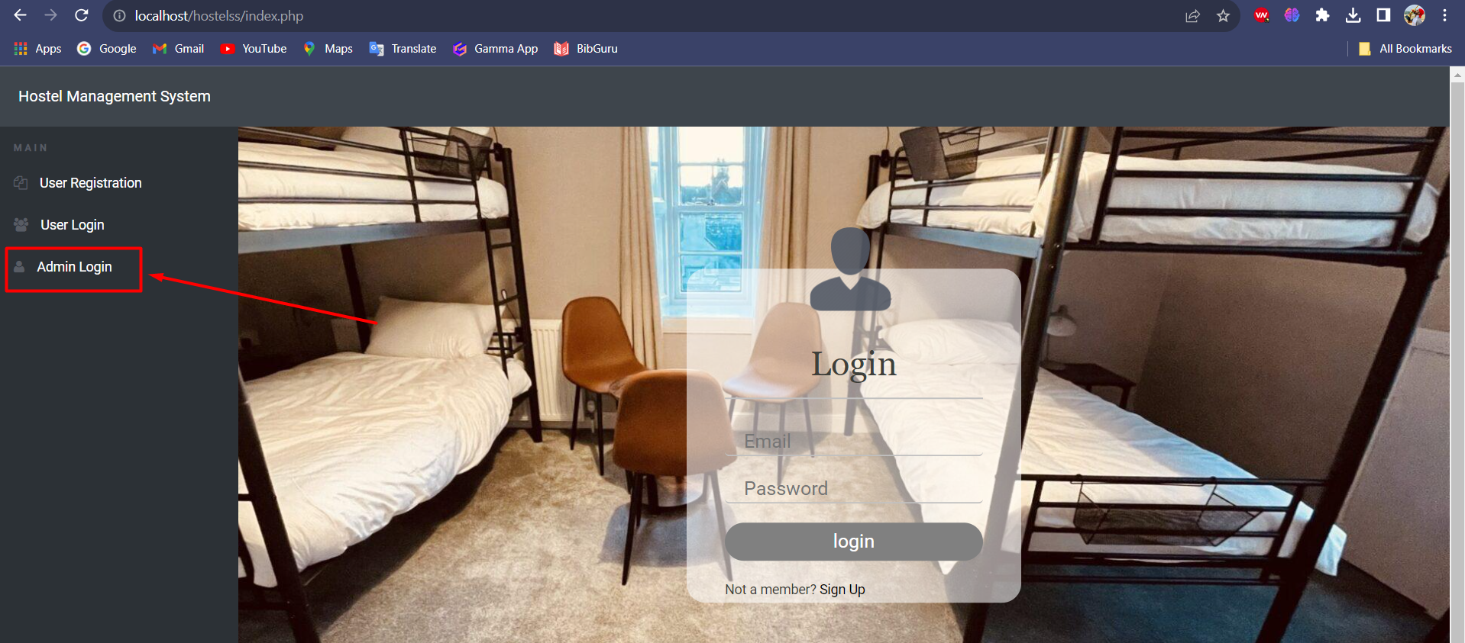

Here when you click this **“Admin Login”** you’ll navigate to Admin login page. The Admin Login Page, which serves as the administrator's point of access and control for the many system functionalities, is a crucial component of the Hostel Management Website. This report provides an overview of the Admin Login Page's functionality and design, including its overall layout and user interface elements.

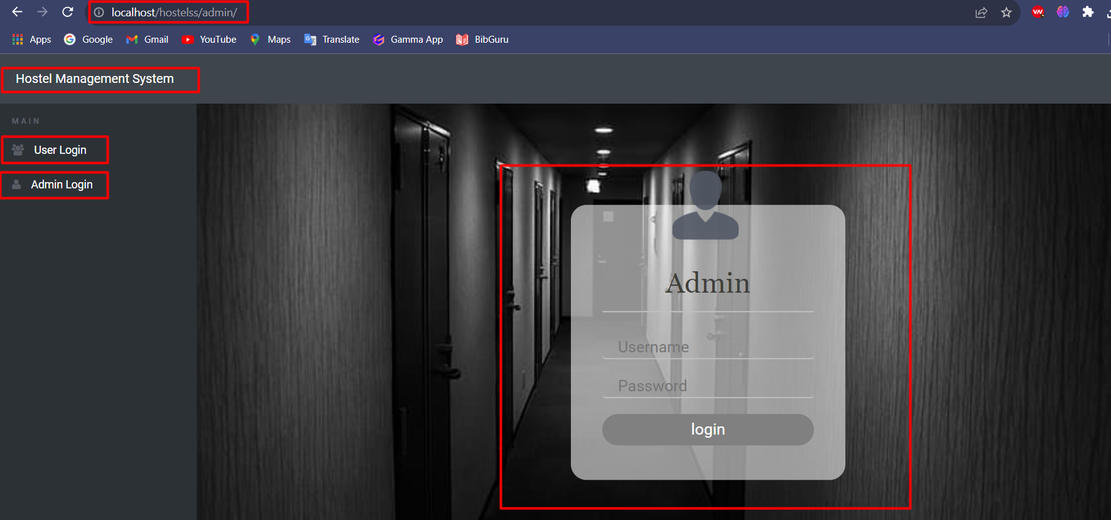

Here this is the user interface for the Admin Login. Here we have a navbar which consist of **“Hostel Management System”** and in the Side bar we have **“User Login” and “Admin Login”.** Here it’ll ask you to enter the username and password. If you enter the user and password it’ll check in the admin table whether the password and mail you’ve entered is correct or not. If that is correct, you’ll redirected to Admin user interface if not you’ll given an alert about the password/email error.

The verification is done using the Database table **“Admin”.** It holds the authenticable data in it.

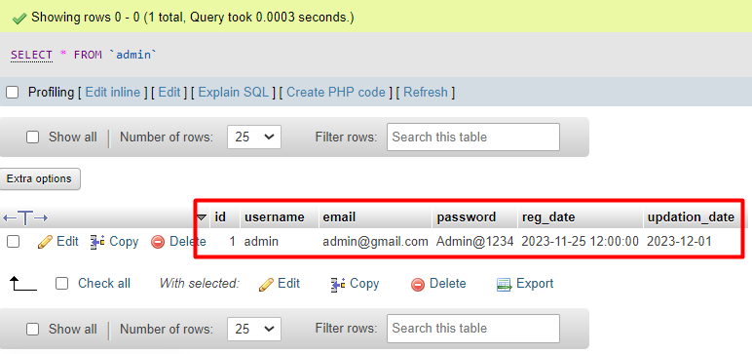

If you type the correct Username and password only it’ll navigate to Admin UI(Admin Dashboard). If you don’t give it’ll give you an error

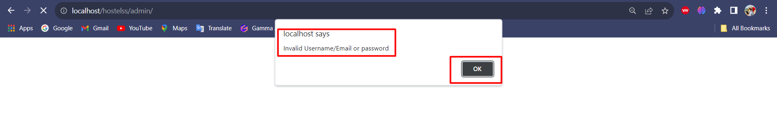

1. **Admin/Dashboard Page**

If the Admin login is correct, you’ll navigate to Admin Dashboard

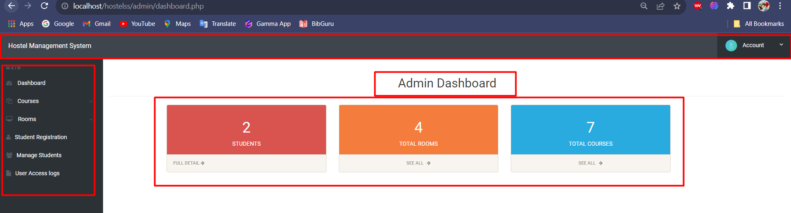

Here we have Navbar, Sidebar and body. In the Navbar we have the topic name **“Hostel Management System” and a Dropdown type “Account”.** When you click on that

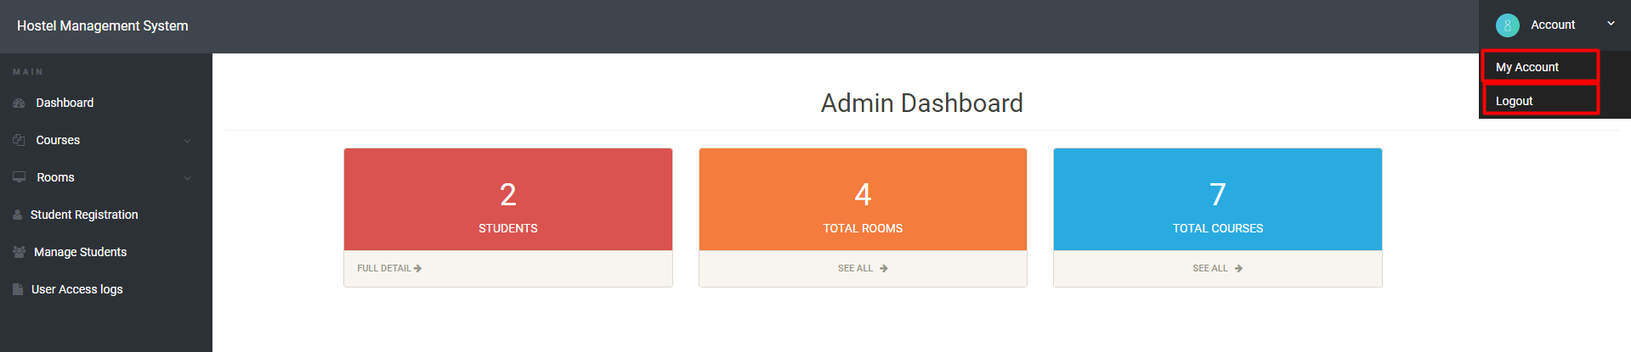

We will have **“My Account”** and **“Logout”**. When we click on **“My Account”**

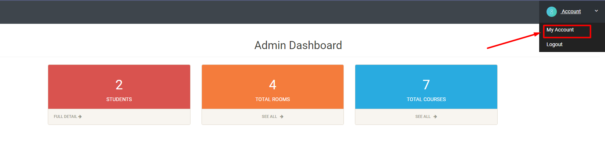

When you click on this it’ll redirect to Admin Profile Page which Contains the information of Admin

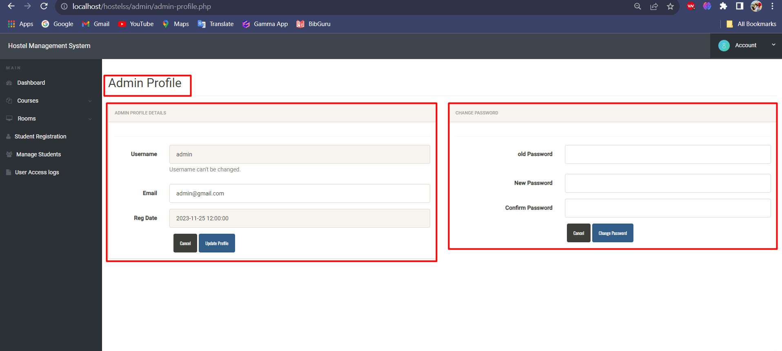

Here we can see the admin details in one Side and Change Password in another side. Using this we can update the details if needed or else we can leave as it is.

When you click on **Logout**

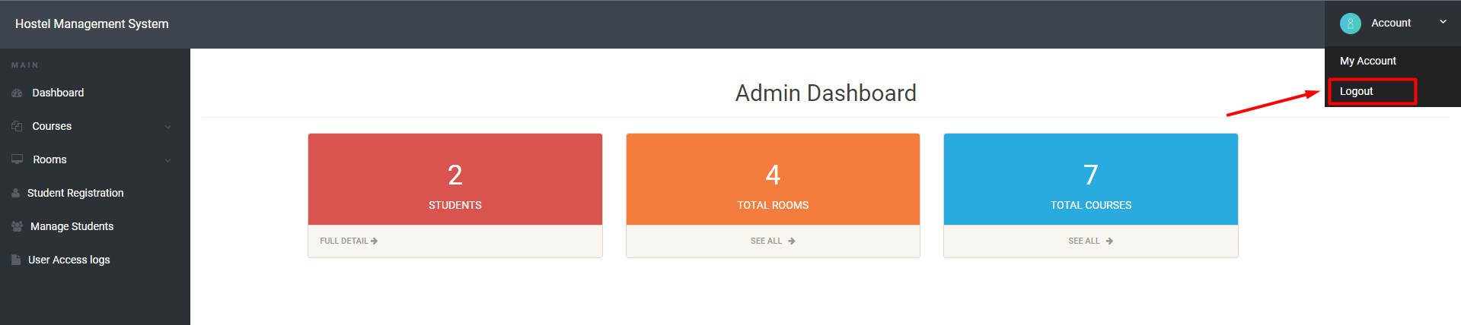

It’ll move to the **admin login page.**

In the sidebar of the admin Dashboard, we have some menus

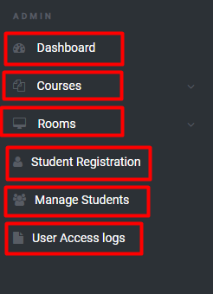

**Dashboard:** Dashboard is the default page after the admin login.

**Courses:** Courses is the page which contains course details. Here we can add new Courses.

**Rooms:** This option allows you to **add a new room** or **manage rooms**

**Student Registration:** Using this we can register room for a student.

**Manage Students:** This page will give you the rooms details

**User Access log:** This option will tell your users login date time and other related entries.

In the body of the Dashboard, we have

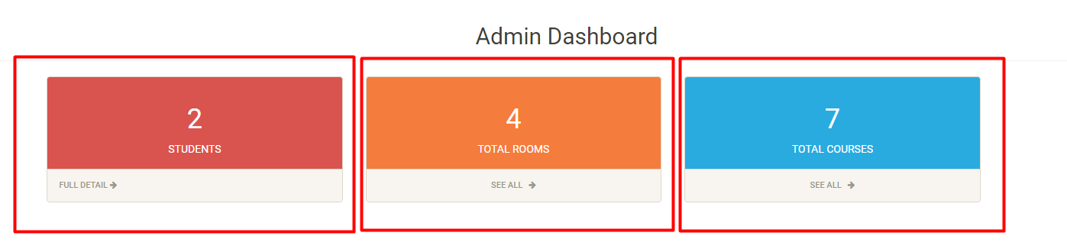

When you click **STUDENTS**, you’ll see the Students Details. When you click on **TOTAL ROOMS**, you’ll see the available rooms. When you click **TOTAL COURSES**, you’ll see Total Available Courses.

1. **Admin / Courses Page**

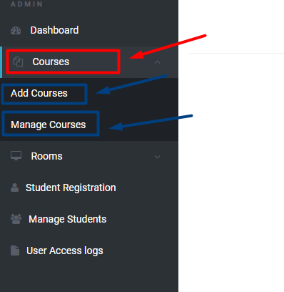

When you click on **Courses** you’ll get

**Add Courses:** Here using this we can add the courses.

**Manage Courses:** Here using this we can manage those courses.

1. **Add Courses**

When you click on **“Add Courses”,** we’ll provide an Interface to add a new course

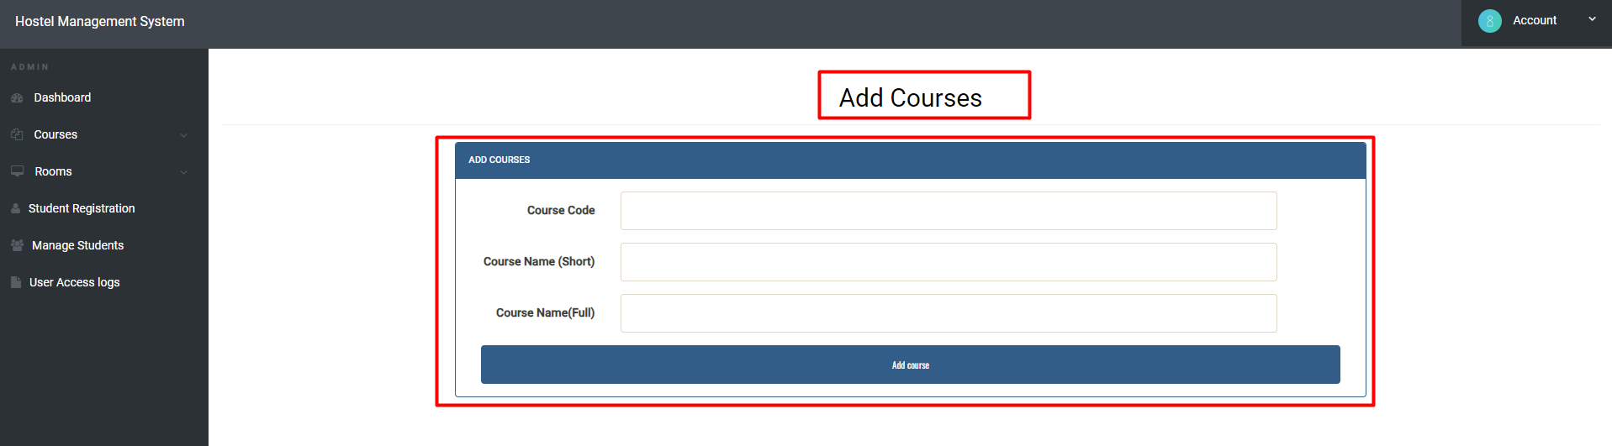

Here you’ll get a form like structure to add a new Course. Here you’ve to add Course Code, Course Name (Short and Full). Once you finish and press the add course button it’ll add in the Database course table.

1. **Manage Course**

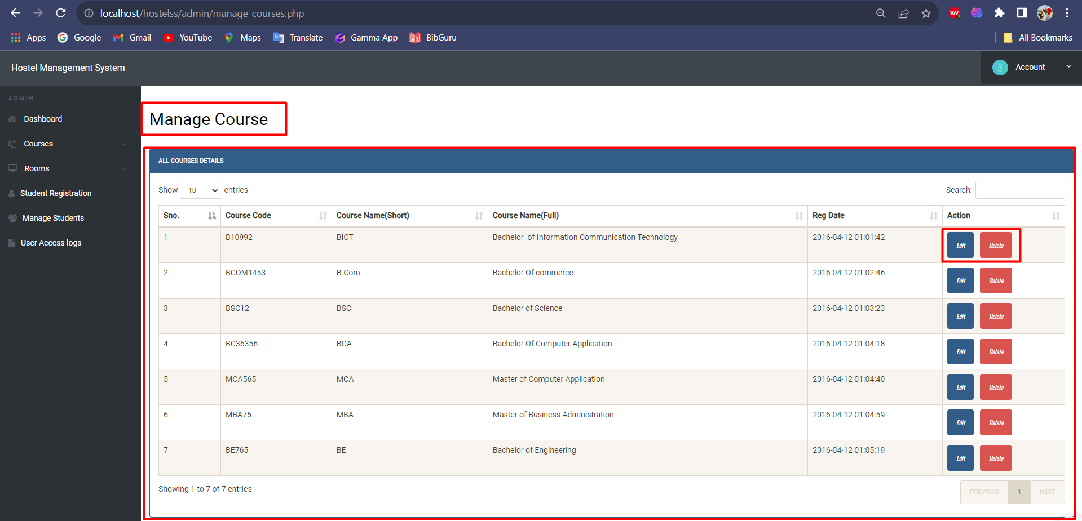

Here in the Manage Course, we have all the available courses in a table like Structure. Here in the Action Column, we have two buttons namely **Edit** and **Delete**. When you click on **Edit**

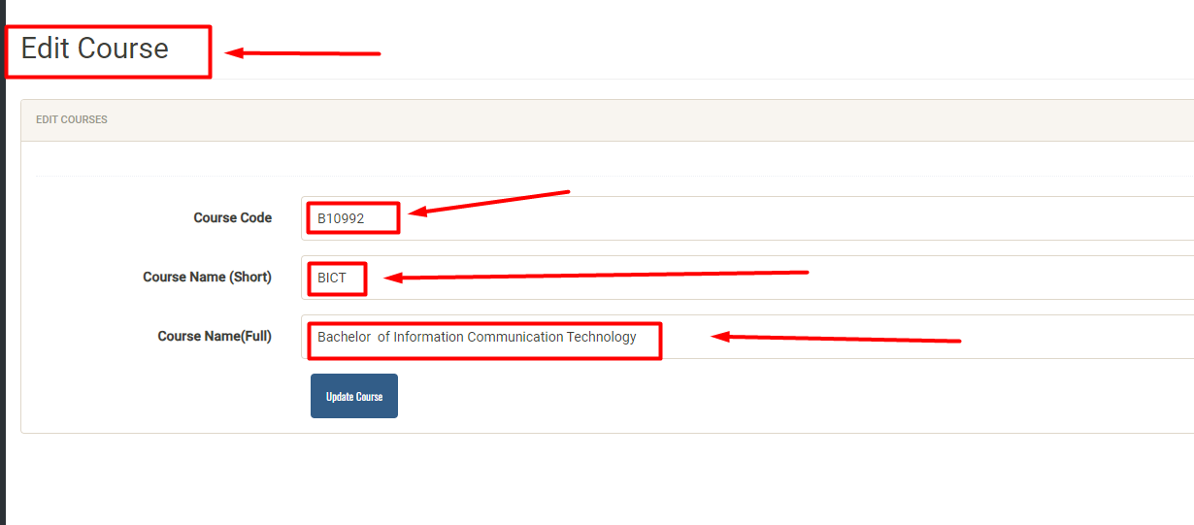

Through this we can edit our clicked Course. And if we change and click on Update, we can update the data. It’ll change in the database table also.

When you click on the **Delete Button**

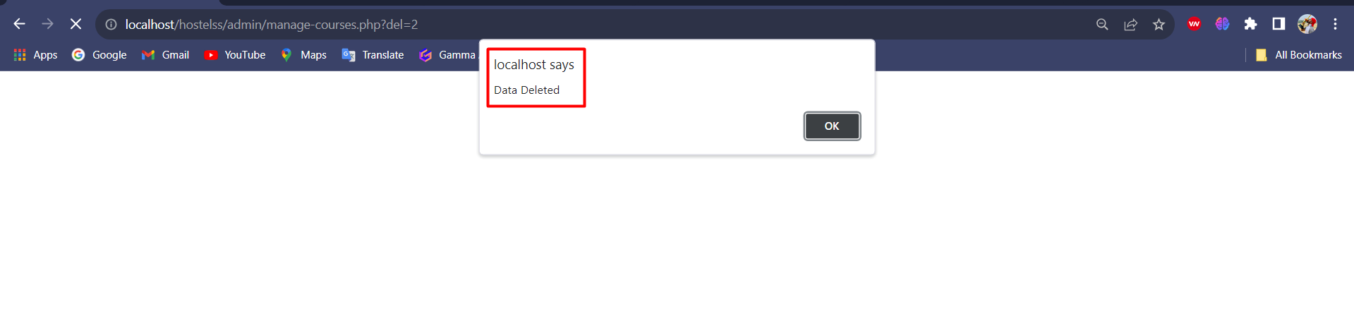

The data will be deleted and give you an alert regarding the data deletion.

1. **Admin / Rooms Page**

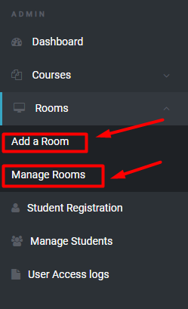

When you click on **Rooms** you’ll get

**Add a Room:** Here using this we can add room.

**Manage Rooms:** Here using this we can manage those rooms.

1. **Add a Room**

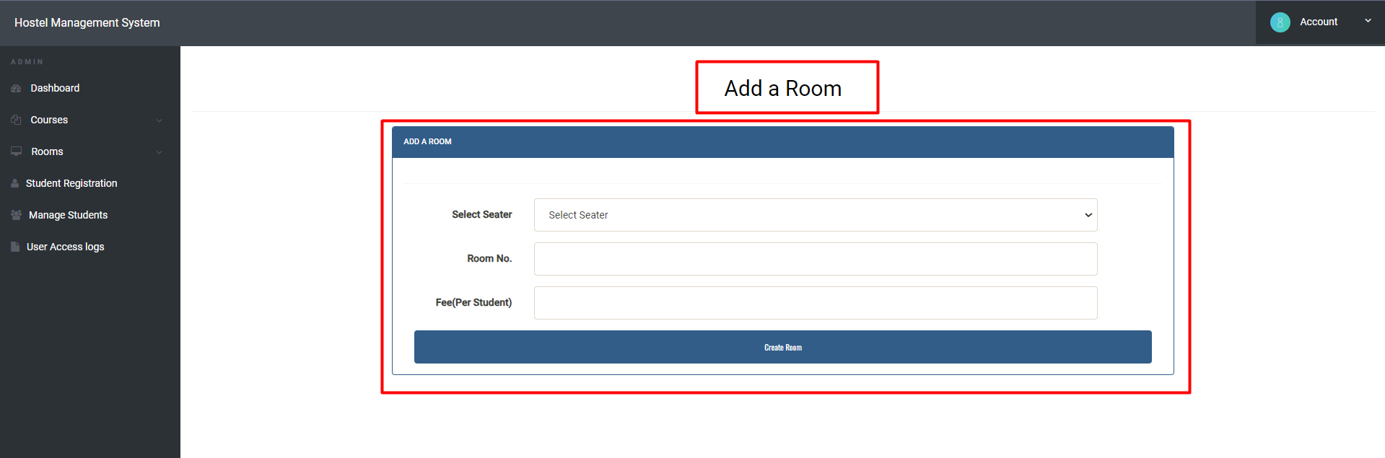

Here we can add a room using this form. And the newly added room will be added to the database table also.

1. **Manage Rooms**

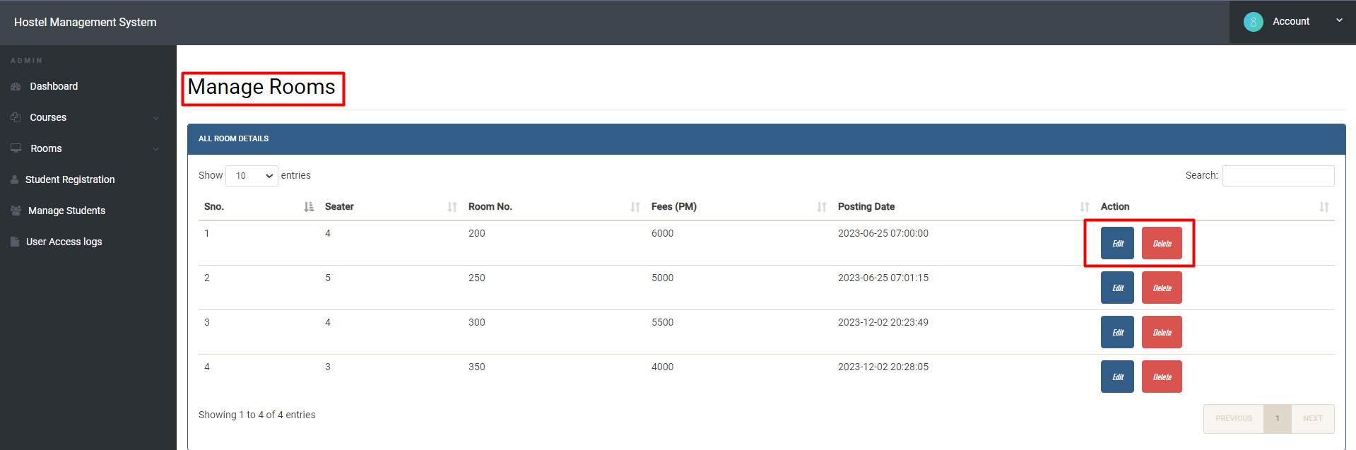

Here we can manage the Available rooms. Those rooms are displayed using the table. In the Action column, we have two actions. **Edit** and **delete** are those two.

1. **Admin / Student Registration**

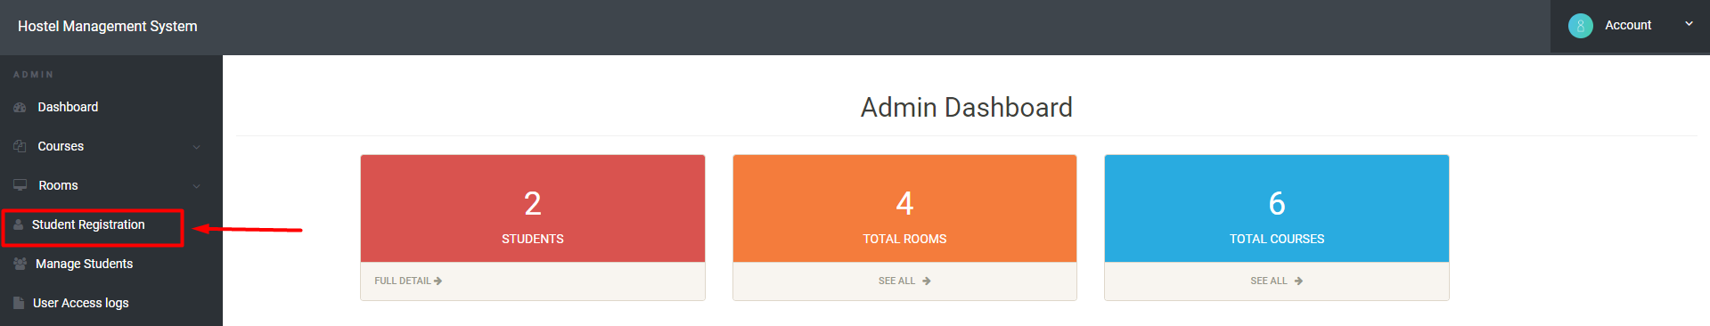

When you click on Student Registration, you’ll redirected to Student Room Registration Page

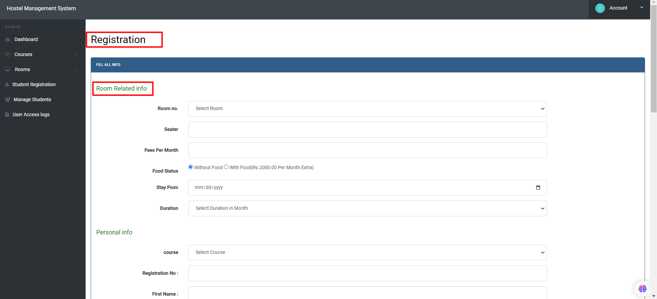

Here the admin can add/reserve room for student.

1. **Admin / Manage Students**

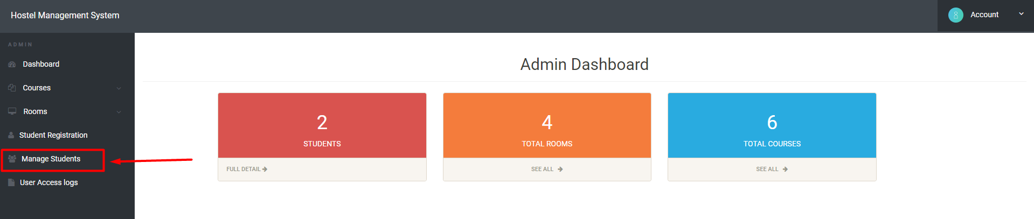

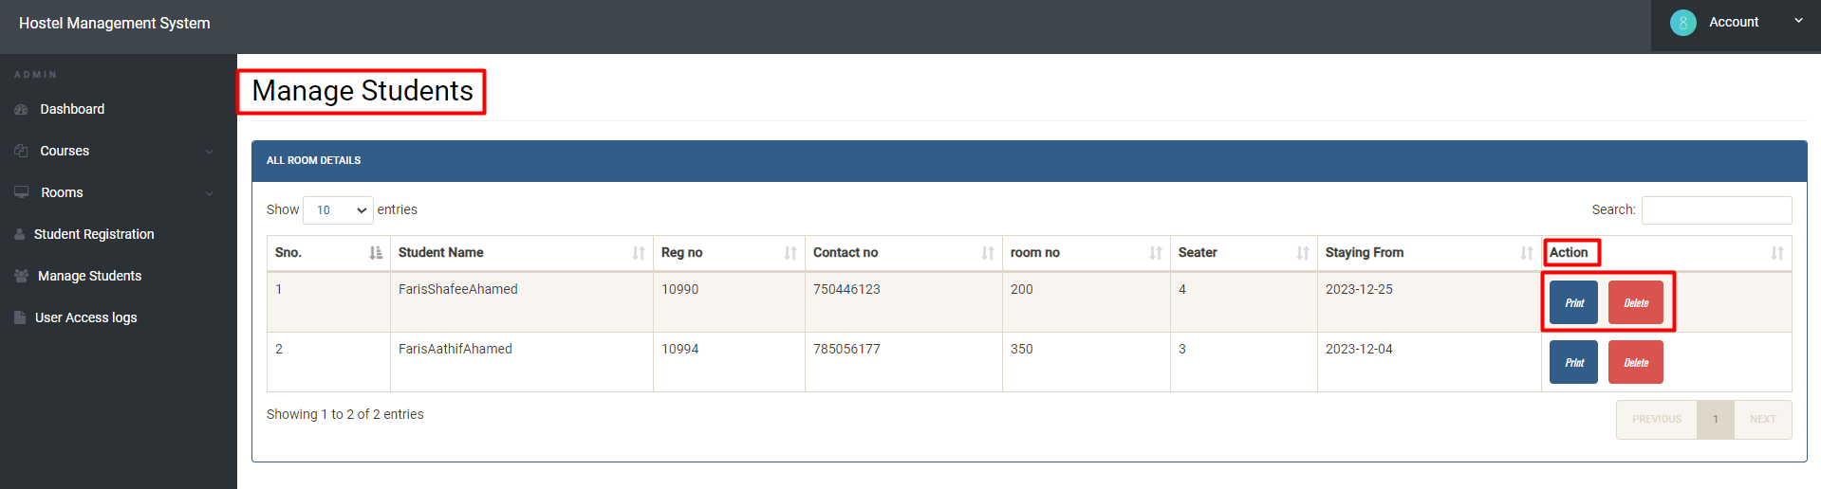

One of the most important parts of our hostel administration system is the Manage Students page, which is made to effectively manage and arrange records of the students that are staying there. All hostelers can maintain their login credentials and associated information in one place on this page. The major objective is to ensure a seamless and well-organized procedure by streamlining the administrative duties associated with student housing.

Here we can see all the student details in the table. In the Action part we have buttons called **Print** and **Delete**. When you click on **Print**

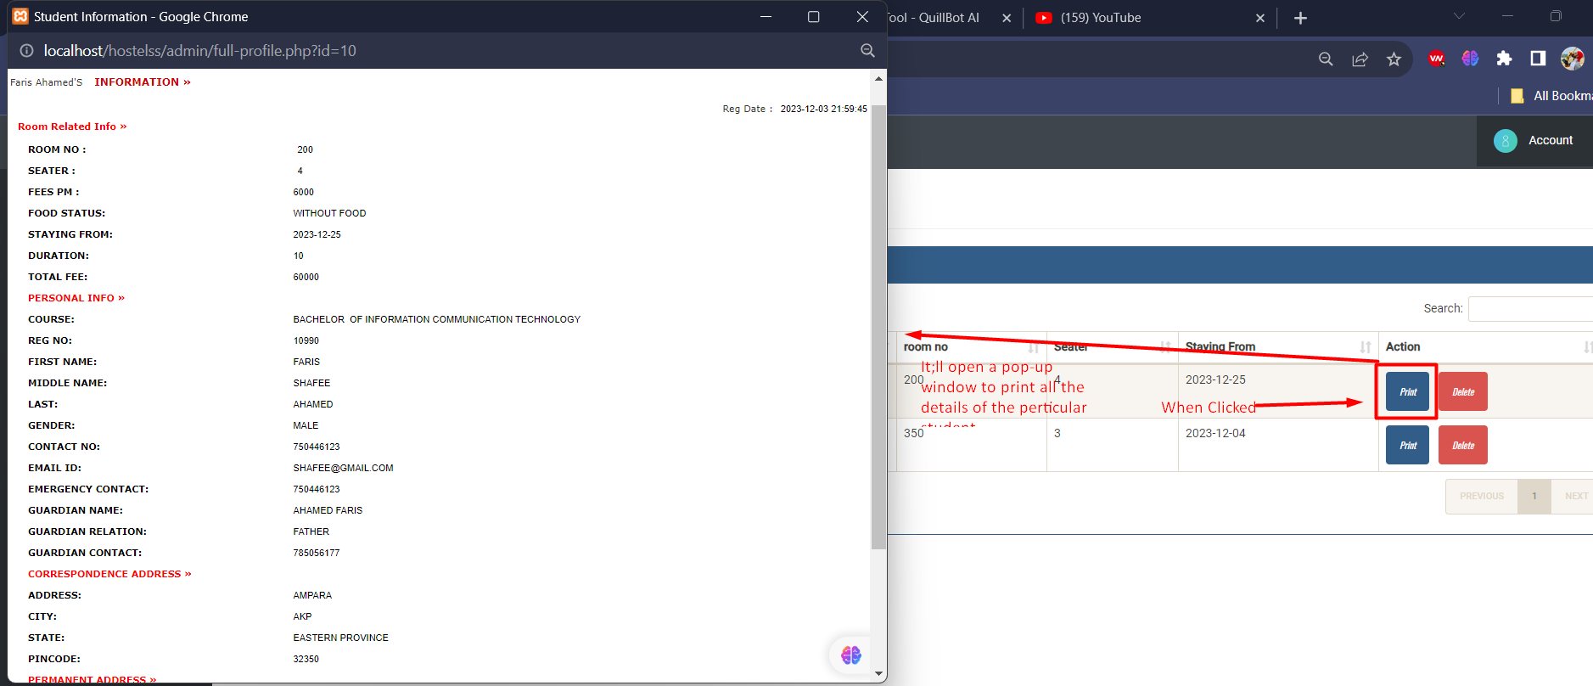

When you click on print, there’ll be a pop-up window to print the details of students. It’ll make the work of admin easier.

If we press delete, the entire details of that particular student will be deleted.

1. **Admin / User Access Logs**

The Access Log Page is one of the most crucial tools for keeping an eye on user activity within a system or application. It is a record-keeping feature designed to capture crucial information such as times, dates, and user log-in details. Here admin can see all the login details of all the students with time, date and related stuffs.

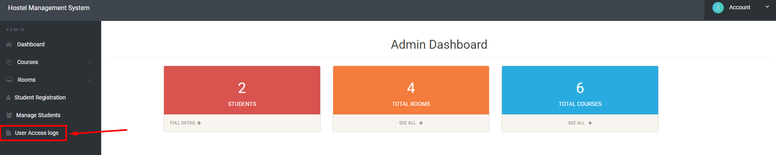

When you click on User Access Logs, you’ll able to see all the user’s login stuffs.

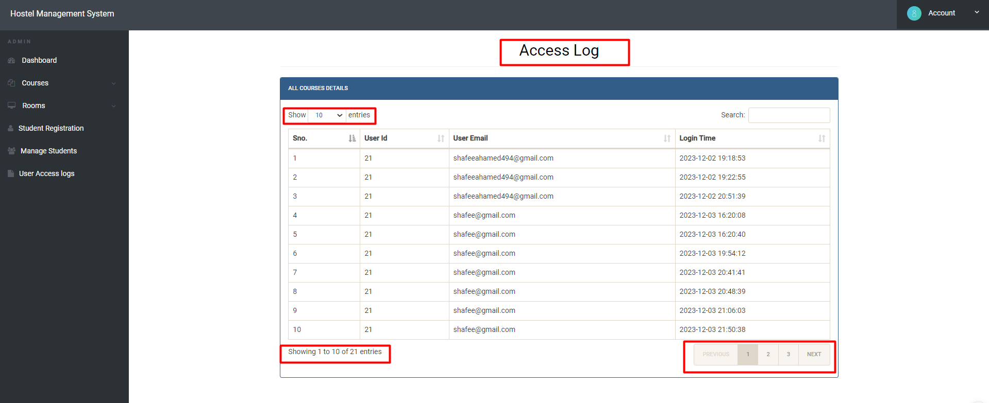

Here we can set the entries to show in the page using the show drop list in the table.